Computer-Aided Drug Design,
Discovery and Bioinformatics Research Group

Sl. No | Photo | Name and Affiliation | Country | Profile link
01 | 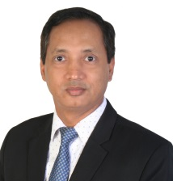 | Prof. Dr. Md. Moklesur Rahman Sarker  M. Pharm. (Thesis), PhD in Pharmaceutical Sciences (Okayama University, Japan), Postdoc (University Malaya, Malaysia)  Head of Academic and Research Affairs  Department of Pharmacy  State University of Bangladesh | Bangladesh | https://scholar.google.com/citations?user=YtXutm0AAAAJ&hl=en  https://www.researchgate.net/profile/Md-Moklesur-Rahman-Sarker
02 | 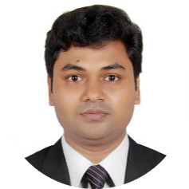 | Mr. Ajoy Kumer  M. Phil (Buet), M.Sc Chemistry, Chittagong University  Senior Lecturer  Department of Chemistry,  Faculty of Science & Engineering, European University of Bangladesh | Bangladesh | https://scholar.google.com/citations?user=F__BD4gAAAAJ&hl=en  https://www.researchgate.net/profile/Ajoy_Kumer2
03 | 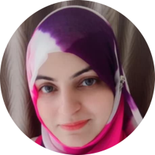 | Dr. Shabana Bibi  PhD (Bioinformatics), MIT, Japan  Postdoc (Computational Genomics), China  Expert: In Silico Drug Design | Pakistan | https://scholar.google.com.pk/citations?user=Lo4JM3wAAAAJ&hl=en  https://www.researchgate.net/profile/Shabana-Bibi
04 | 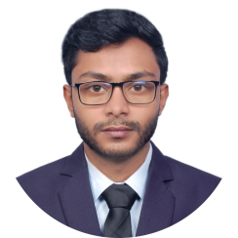 | Mr. Abdus Samad  M.Sc. Genetic Engineering, Jashore University of Science and Technology  Research Fellow,  Health Med Science Research Network  Expert: Molecular Dynamics Simulation | Bangladesh | https://scholar.google.com/citations?user=3520UFoAAAAJ&hl=en  https://www.researchgate.net/profile/Abdus-Samad-9
05 | 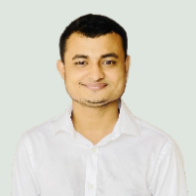 | Mr. Shopnil Akash  M. Pharm., Daffodil Int. Univ.  Research Assistant, High Impact Research Project on Immunity, Ministry of Education, Bangladesh | Bangladesh | https://www.researchgate.net/profile/Shopnil_Akash  https://loop.frontiersin.org/people/1833092/overview
06 | 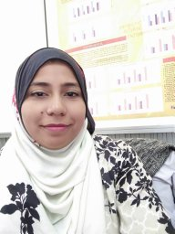 | Dr. Sana Shamim  Assistant Prof.  Dept. of Pharm. Chemistry  DOW University of Health Sciences | Pakistan | https://scholar.google.com.pk/citations?user=OHsz0XwAAAAJ&hl=en  https://orcid.org/0000-0001-8630-8644
07 |  | Mr. Aqeel Ahmed  M Sc. Biotechnology  University of Central Panjab, Pakistan | Pakistan | https://scholar.google.com/citations?user=ZOGe7x4AAAAJ&hl=en
08 |  | Dr. Ali Ashraf  University of Foggia  Italy | Italy | https://www.researchgate.net/profile/Ashraf-Ali-7
09 |  | Dr. Amol Patil  Assistant Professor in Medicinal Chemistry  SKN College of Pharmacy, Maharashtra, India | India | https://www.researchgate.net/profile/Ashraf-Ali-7
10 | 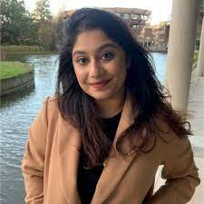 | Mahinoor Fairooz  Lecturer,  Department of Pharmacy,  Primeasia University | Bangladesh | https://www.researchgate.net/profile/Mahinoor-Fairooz
11 | 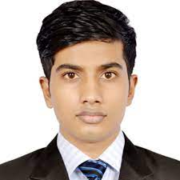 | Anwar Parvez  Department of Pharmacy  Daffodil International University. | Bangladesh | https://www.researchgate.net/profile/Anwar-Parvez
12 | 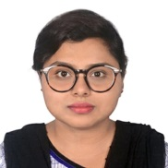 | Bonna Ghosh  Pharmacist  United Hospitals Ltd. | Bangladesh | https://www.linkedin.com/in/banna-ghosh-500526115/?originalSubdomain=bd
13 | 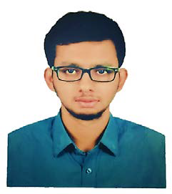 | Md. Marufur Rahman Moni  Development Pharmacist  Eskayef Pharmaceuticals Ltd. | Bangladesh | www.researchgate.net/profile/Md_Marufur_Rahman_Moni
14 |  | Md. Abdus Salam  Analytical R & D Officer  Renata Ltd. | Bangladesh
15 | 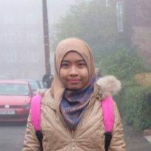 | Jawairiah Remali  M. Sc. in Biomedical Sciences  Universiti Kebangsan Malaysia (UKM)  Research Assistant  Institute of System Biology, UKM | Malaysia | https://www.researchgate.net/profile/Juwairiah-Remali
16 |  | Noorjahan Aktar  B. Pharm. Professionals  JUST | Bangladesh
17 |  | Sabreena Aleem Nabeela  PhD Scholar  University at Buffalo, United States | Bangladesh | https://www.linkedin.com/in/sabreena-aleem-nabeela-3b0410230/?originalSubdomain=bd
18 | 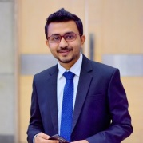 | Syed Abu Hasnat  M. Pharm. (Pharmaceutical Technology)  University of Dhaka | Bangladesh | https://www.researchgate.net/profile/Syed-Abu-Hasnat
19 | 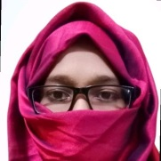 | Sultana Jannat  B. Pharm. (Hons.)  IIUC | Bangladesh | https://www.linkedin.com/in/sjannat-ab2708/?originalSubdomain=bd
20 |  | Alaa Tammam  Pharmacist  An-Najah National University  Palestine | Palestine | https://www.researchgate.net/profile/Ala-Tammam
21 |  | Mohammed Emon  Bachelor of Science (Hon's)  Department of Biotechnology and Genetic Engineering  Bangabandhu Sheikh Mujibur Rahman Science & Technology University, BSMRST | Bangladesh | https://www.linkedin.com/in/aakilkhanemon/
22 |  | Muhammad Safdar  M. Phil. (Molecular Biology)  University of the Punjab, Lahore | Pakistan | https://www.linkedin.com/in/dr-muhammad-safdar-9646b844/?trk=public_profile_browsemap&originalSubdomain=pk

